In this assignment we are following the steps applying in the “Data Mining: A Preprocessing Engine” research paper to normalize our dataset suing three methods of normalization such as z-score, min-max, and decimal point normalization. Also, we are using three different type of methodology to test the data training set. The first one is the decision tree, however you replace ID3 for the J48 option in WEKA. The second is the K-Nearest Neighbor (KNN). Lastly, we used an artificial neural network transfer function to model for dataset, which was coded in R.

Different Approaches Results:
Approach | Min-Max |  | Z-Score |  | Decimal Scaling
Dataset
Accuracy | 84.01 | 78.40 | 81.29 | 82.31 | 84.01 | 78.40
Tree Growing time/sec | 0.03 | 0.06 | 0.04 | 0.01 | 0.03 | 6
No. of Leaf Nodes | 2 | 6 | 2 | 156 | 2 | 0.06

The Accuracy of the data mining techniques:
Technique | Min-Max Accuracy | Z-Score Accuracy | Decimal Point Accuracy
Rules generation | 99.31 | 100 | 99.31
KNN | 72 | 80 | 72
TF | 61 | 61 | 61
Analyzing normalized datasets with neural network model

$trainset
[1] 147

$testset
[1] 147

Z-score model Analysis

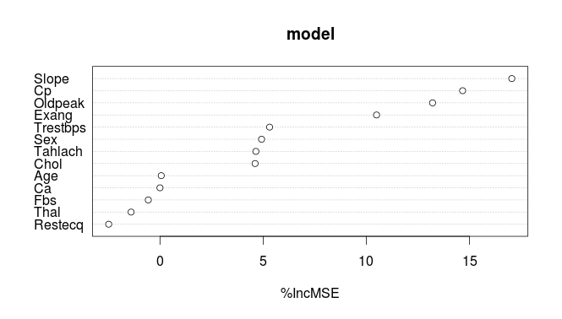

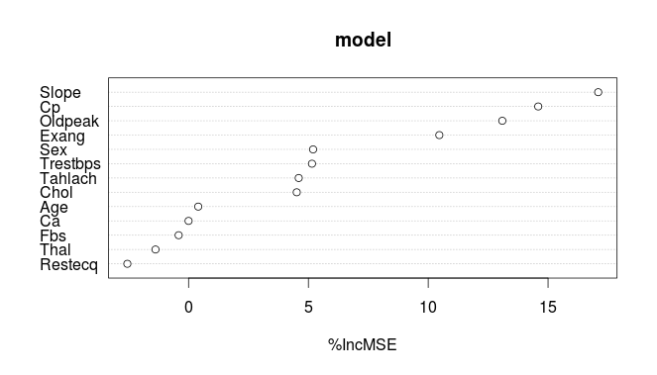
Call:
randomForest(formula = Num ~ ., data = training,
importance = TRUE, keep.forest = TRUE)
Type of random forest: regression
Number of trees: 500
No. of variables tried at each split: 4

Mean of squared residuals: 1.046372
% Var explained: 39.13

Max-Min Model Analysis

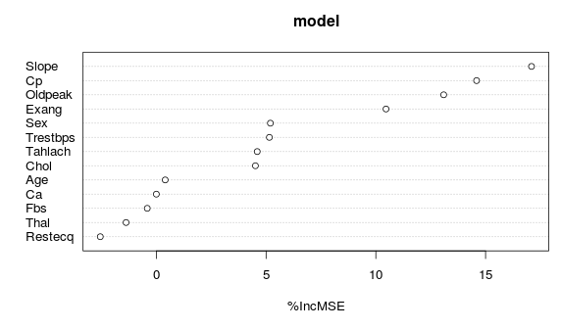
Call:
randomForest(formula = Num ~ ., data = training,
importance = TRUE, keep.forest = TRUE)
Type of random forest: regression
Number of trees: 500
No. of variables tried at each split: 4

Mean of squared residuals: 1.046372
% Var explained: 39.13

